

ESCOLA SECUNDÁRIA EÇA DE QUEIRÓS

ENGLISH – EFA SECUNDÁRIO

School Year 2009/2010

Look around you… Pedro Aurélio S/13

- Complete the sentences by conjugating the verbs in brackets in the Imperative.

- Recycle (to recycle) the waste.
- Use (to use) public means of transport.
- Spare (to spare) energy as much as possible.
- Buy (to buy) eco friendly houses.
- Try (to try) to spread the word about the importance of treating this world right.

- Final Task: Choose one of the following campaigns and create a leaflet that aims at drawing people’s attention to the importance of the environment nowadays. Don’t forget to use the Imperative to give advice.



(preservation of forests; oceans and sealife)

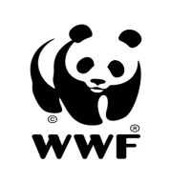
(protection of the endangered species)

Greenpeace

Do not spill oil in the water. Protect the environment.
Do not contaminate the water. Vary your diet as to fish. Respect enclosed seasons.
Protect endangered species.
Do not burn the woods and preserve the forests.

.

Good Luck ☺

